GB-SAR PSI Data Description

Edited by WANG Peng 2021.7.23

**1 Part_01 Average image sequence**

“AVESUBSET_SXX.mat” is the average image data file containing four sub files as shown in Figure 1.

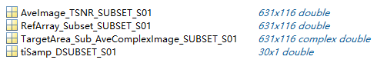

Fig.1 File structure of “AVESUBSET_SXX.mat”

(1) The AveImage_TSNR_SUBSET_SXX is the TSNR matrix.

(2) The RefArray_Subset_SUBSET_SXX is the reference matrix, which is used to mark whether it is a PS point in this image subset.

(3) The TargetArea_Sub_AveComplexImage_SUBSET_SXX is complex image data.

(4) The tiSamp_DSUBSET_SXX is image acquisition time array.

**2 Part_02 Atmospheric correction of interferograms**

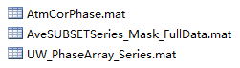

Fig.2 Atmospheric correction result files

(1) The AtmCorPhase.mat is the atmospheric model phase of interferograms.

(2) The AveSUBSETSeries_Mask_FullData.mat file consists of mask matrix, row and column number and coordinate matrix, as shown in Figure 3.

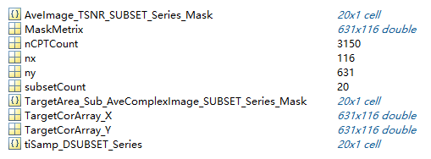

Fig.3 File structure of AveSUBSETSeries_Mask_FullData.mat

(3) The UW_PhaseArray_Series is the atmospheric correction results of the unwrapped interfero-grams.

**3 Part_03 Linear deformation rate estimation**

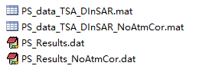

Fig.4 Result files of linear deformation rate estimation

(1) The PS_Results.dat is the estimated deformation rate after atmospheric correction.

(2) The PS_Results.dat is the estimated deformation rate without atmospheric correction.

(3) The PS_data_TSA_DInSAR.mat stores PS point phase data and coordinate information with atmospheric correction.

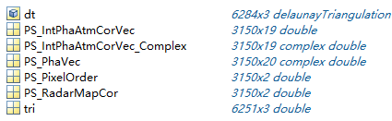

Fig.5 File structure of PS_data_TSA_DInSAR.mat

(4) The PS_data_TSA_DInSAR_NoAtmCor.mat stores PS point phase data and coordinate information without atmospheric correction.

**4 Part_04 Deformation series results**

The DisPhaseSeries.mat is the deformation sequence image data, without time-domain low-pass filtering.